**Broadcast English text**

## 1. Purpose

In this lesson, we will learn how to use Raspberry Pi board drive the speech synthesis module to realize the English broadcast function.

**2.Preparation**

**2.1 About wiring**

|  |  |
| --- | --- |
| Speech synthesis module | Raspberry Pi board |
| SCL | SDA |
| SDA | SCL |
| VCC | 5V |
| GND | GND |

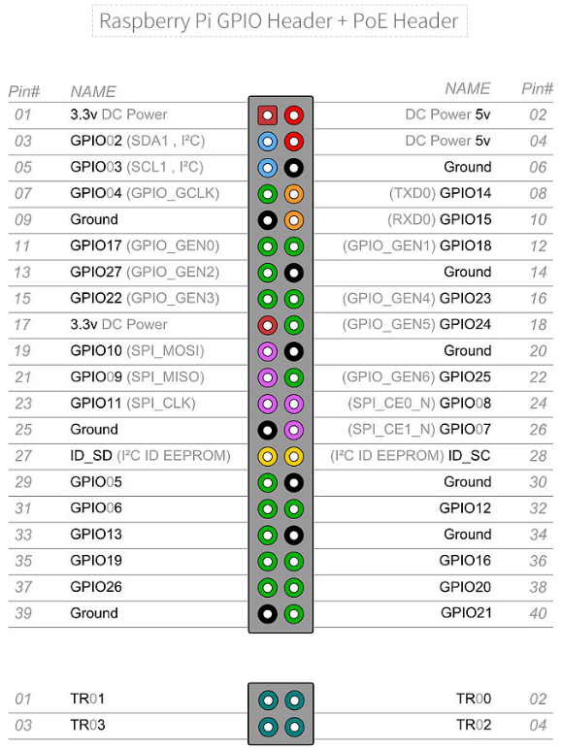

2.2 You need to open the IIC service of Raspberry Pi board.

We can input following command to check whether I2C is successfully started.

lmusb

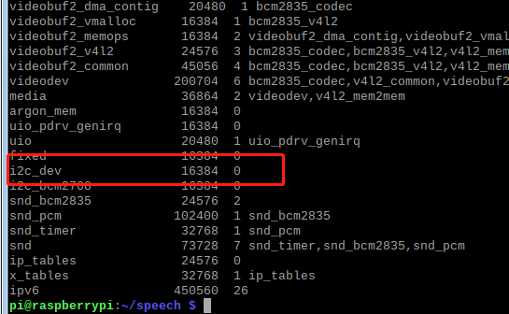

2.2 Install I2Ctool

Input following command in command terminal,

sudo apt-get install i2c-tools

2.4 Scan all i2c devices on a certain bus, and print out the device i2c bus address.

i2cdetect -y -a 1

IIC address is 0x50.

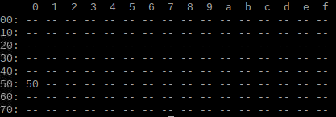

****3. S**peech synthesis **module protocol****

The speech synthesis module is configured and used in accordance with the specified data frame through the I2C communication.

More details, please check [1.Introduction]--[1.2Communication protocol].

1. **Code**

About code, please view **English_speech.py** file.

**5. Running code**

Input following command in command terminal of Raspberry Pi.

python3 English_speech.py

**6. Experimental phenomena**

After the program is downloaded successfully, Xiaoping will broadcast "hello yahboom intelligent Technology".

Then, Xujiu will broadcast "Welcome to use yahboom intelligent technology voice broadcast module.